**[18CSC305J(Artificial Intelligence)](https://classroom.google.com/c/MjU3Mjk3ODY4MDA2" \t "https://classroom.google.com/c/MjU3Mjk3ODY4MDA2/a/Mjc0MDQxNDQ0OTA5/_self)**

VIKASH MISHRA

RA1811003010344

1. TECH CSE 3RD YR

F1 SCETION

18CSC305J - Artificial Intelligence lab

EXPEIMENT - Uncertain Methods for an Application

STATEMENT - To represent uncertain knowledge, where we are not sure about the predicates, we need uncertain reasoning or probabilistic reasoning.

We can find the probability of an uncertain event by using the below formula.

IMG_256

P(¬A) = probability of a not happening event.

P(¬A) + P(A) = 1.

IMG_256

Where P(A⋀B)= Joint probability of a and B

P(B)= Marginal probability of B.

If the probability of A is given and we need to find the probability of B, then it will be given as:

IMG_257

QUESTION - Does the patient have malignant tumour or not?

A patient takes a lab test and the result comes back positive. The test returns a correct positive result in only 98% of the cases in which a malignant tumour actually present, and a correct negative result in only 97% of the cases in which it is not present. Furthermore, o.oo8 of the entire population have this tumour.

SOLUTION -

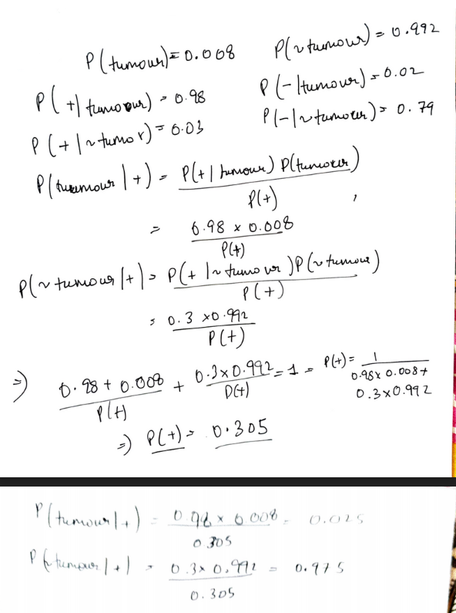

CODE -

# calculate P(A|B) given P(B|A), P(A) and P(B)

def bayes\_theorem(p\_a, p\_b, p\_b\_given\_a):

p\_a\_given\_b = str(p\_b\_given\_a \* p\_a) + '/ p\_pos'

return p\_a\_given\_b

# P(T)

p\_t = 0.008

p\_pos\_given\_t = 0.98

p\_neg\_given\_n\_t = 0.97

p\_t\_given\_pos = bayes\_theorem(p\_t, 'p\_pos', p\_pos\_given\_t)

p\_n\_t\_given\_pos = bayes\_theorem((1-p\_t), 'p\_pos', (1-p\_pos\_given\_t))

print('P(T|+ve) =',p\_t\_given\_pos)

print('P(~T|+ve) =', p\_n\_t\_given\_pos)

if(p\_t\_given\_pos > p\_n\_t\_given\_pos):

print('\nPatient has tumor')

else:

print('\nPatient has no tumor')

OUTPUT -

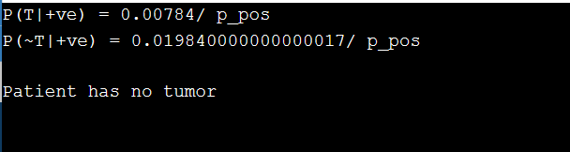

RESULT -

The given program was executed successfully and the result obtained matched the calculated result.